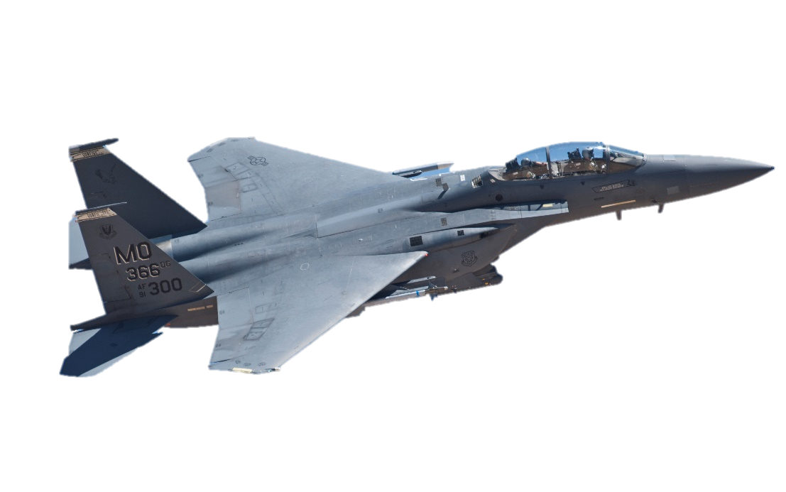
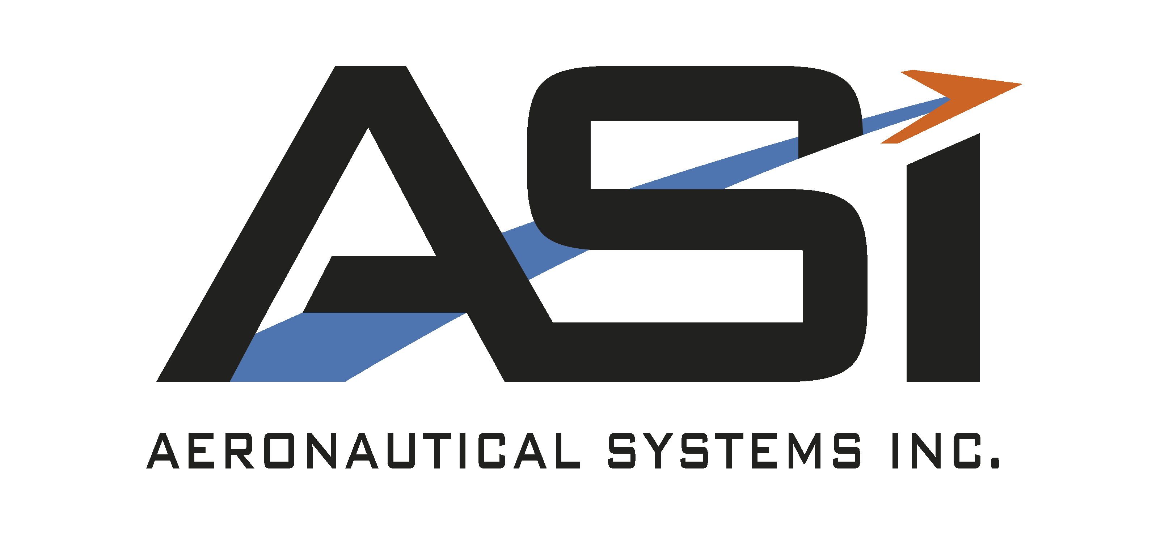
We are looking for several students to join us for the summer of 2026!
ASI’s main goal is to keep military fleets in the air. From the iconic F-16, to the MH-60s used by the Coast Guard, we support many types of exciting aircraft. At ASI you can work next to actual aircraft parts and see all the work that goes into making a 40 thousand lb. plane stay airborne!

12040 South Lakes Drive Suite 203
Reston, VA 20191
www.aeronautical.com
INTERN AT AERONAUTICAL SYSTEMS, INC
Summer 2026
What you can expect during our internship program:
- Experience Work Life.
The opportunity to learn and gain perspective on the working world.
- A Work Space. Have a physical space to work and adequate tools to perform your job.
- Direction.
A supervisor who is available, experienced and knowledgeable in your field.
- Professional Projects.
- Get PAID!
- Grow yourself and your resume. Connecting/ networking with other students, employees and executives.

If you are interested,
email Caryn Lilly at hr@aeronautical.com to tell us about yourself, and why you would be a great fit at ASI!

